Analysis of Catch Quota for Kemedukl and Maml in Palauan Water
Aug 24, 2013
Project: Stock Assessment for Humphead Wrasse and Bumphead Parrotfish

Alan Friedlander and Haruko Koike
Fisheries Ecology Research Lab
University of Hawaii

Executive Summary:

Catch limits for kemedukl and maml in Palauan water were calculated based on underwater visual census data collected during May 2013 and basic life history parameters collected from publications using yield per recruit simulation model created by Sadovey et al. (2007). Optimum fishing mortality for maximum sustainable yield was calculated to be 0.2 for Maml and 0.4 for kemedukl. However, we suggest using a much lower fishing mortality (0.01-0.1) for calculating the catch limit for the following reasons:
- The model assumes the population is stable. However, Palau’s stock is still recovering from previous overfishing, and therefore not stable in its size structure or its population size.
- The model assumes that the population is one large population under homogenous mixing. However, both kemedukl and maml population are highly likely to be divided into metapopulations in Palau.
- The model assumes that the fecundity for a female is the same throughout its life. However, larger females are known to produce more and higher surviving larvae. Therefore, the model does not consider the additive effect from loss of larger fecund females.
- The model assumes that mortality is solely driven by fishing effort (natural mortality is fixed). Although fishing does contribute to much of the mortality, it is not wise to exclude the change in other mortality pressures such as increased natural predation and competition.
- Both kemedukl and maml have patchy distributions and thus the estimations of population size have large confidence intervals. It is wise to keep the fishing intensity low when there is a high level of uncertainty in stock size.

Additionally, both kemedukl and maml have high value for other economical and sociological activities such as ecotourism and subsistence fishing. Considering the impact of fishery to these non-fishery activities, we propose to keep the catch limit low.
With the fishing mortality rate of 0.1, the catch limit is calculated to be 4669 individuals for kemedukl and 1234 for maml. However this is about three times greater than the average annual catch of the previous fishery (average annual landing for kemedukl was 1667 and 433 for maml). Knowing that the previous fishery collapsed with a third of the proposed catch limit, we suggest using a lower fishing mortality rate such as 0.01.
A fishing mortality rate of 0.01 will generate a catch limit of 487 for kemedukl and 129 for maml. This is about a quarter of the previous annual landing. By keeping this lower fishing mortality, it will also allow the recovery process of the stock to continue. With this kind of small allowable catch, we suggest opening the fishery to selective use such as for artisanal or customary take.

Analysis Method:
Using the underwater visual census data collected during May 2013, preliminary catch limit has been calculated based on the stock’s size structure and population size. Optimum fishing mortality was simulated using a user interface developed by Sadovy et al. 2007. The catch limit was calculated based on the modified equation 19 of Sadovy et al. 2007, where the catch is calculated based on the estimated number for each size bin, fishing mortality, and natural mortality.
S_{l} F
C = Σ ------------ * N_{l} * (1-e^-(M+S_{l}F)) …………………… (1)
l M + S_{l} F

C = Estimated catch based on the specified fishing mortality
F = User defined fishing mortality
S_{l} = Gear selectivity for each size class l
M = Natural mortality
l = Size class

Assumptions made for using the Sadovy et al. 2007 surplus production model:
- For stock assessment model parameters, we used Sadovy (2007) parameter for humphead wrasse (maml) and FishBase (2013) and Kobayashi et al. (2011) for bumphead parrotfish (kemedukl).
- We assumed that all reefs are pristine and are not at risk from pollution or destruction
- We assumed that all reef areas (backreef, forereef, fringing reef, and lagoon patch reef) will be fished under the same fishing intensity thus we used uniform fishing intensity.
- We assumed that fishermen only caught fish larger than 55 cm (the gear selectivity of fishing was 1.0 after the size of 55 cm).
- Due to the lack of fecundity data, recruitment parameter based on gonad weight for bumphead parrotfish was assumed to be the same as humphead wrasse.
- The model assumes the fish stock is one large population.

Current Population Size Estimation:
Current population estimate was calculated by multiplying median fish density within each habitat strata by the total area size of the corresponding habitat. Median density was used instead of the mean density due to the large counts of zeros (which was caused by the fish’s schooling behavior and patch distributions).

A total of 61,845 (556,605 kg) kemedukl and 37,071 (151,884 kg) maml were estimated to exist in the waters of Palau. Note that due to the nature of these species (e.g., low density and patchy distributions), both species have large variations in the estimation of population size. This should be considered when proposing catch limits.

Table 1. Density, area size, and estimate population size for each habitat strata. Numbers in parentheses are standard deviations.
Habitat Type | No. of transects | Area size (ha) | Kemedukl no. /ha | Maml no./ha | Est. Kemedukl Number | Est. Maml Number
Fringing reef | 16 | 308 | 0.75 (2.80) | 1.05 (1.82) | 232  (0-1093) | 323  (0-884)
Backreef | 8 | 608 | 0.85 (1.10)* | 0.89 (0.78) | 518*  (0-669) | 543  68-1017)
Forereef | 40 | 14102 | 1.23 (7.70) | 0.97 (1.53) | 17382  (0-125971) | 13698  (0-35311)
Patch reef | 26 | 28399 | 1.56 (2.68) | 0.79 (1.59) | 44231  (0-120379) | 22508  (0-67729)
Total | 90 | 43417 | -- | -- | 61845  (0-248112) | 37071  (43 – 104941)
*We used 75% quartile of the population density for Kemedukl in Backreef since median density was 0

Previous Market Data:
Market data for kemedukl and maml were provided by Palau Department of Marine Resources. Preliminary examination of these data show high landings for kemedukl (40,000 lbs [18,000 kg] in 1995) until the late 1990s, after which time catch dropped sharply. Landings for maml were at low levels until the late 1990s, when they increased sharply and then declined very rapidly within a few years (Figure 1).
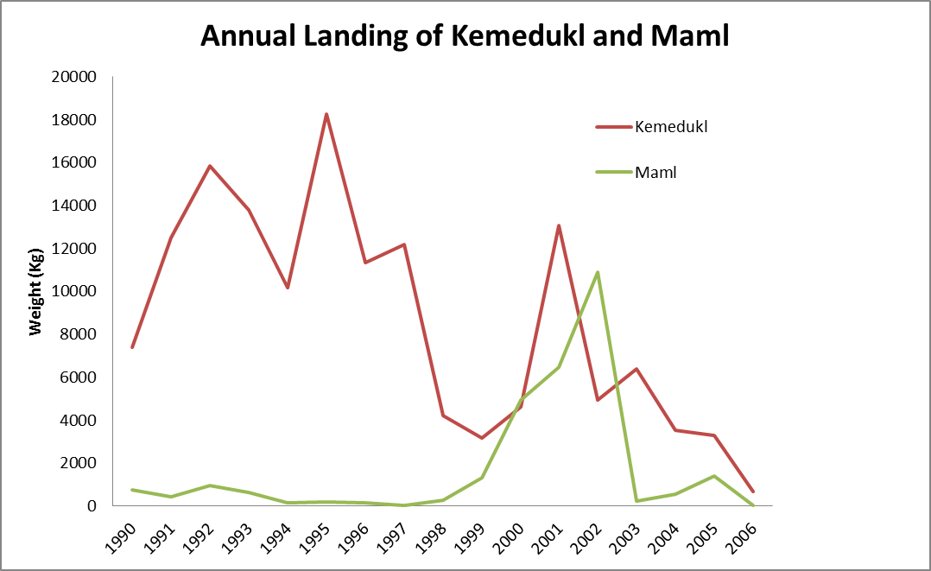
Figure 1. Market data of kemedukl and maml in Palau from 1990 to 2006.
We calculated estimates of the number of landings using an average weight for each species (Table 2 and Table 3). Average number of landing over the years was 8547 kg for kemedukl and 1731 kg for maml. This is 1.5% and 1.1% of the current population respectively. It is important to remember that even with this low number of catch, the stock was depleted to the point of fishery closure.
Table 2. The average weight of each species based on the mean standard length in FishBase. SL=Standard Length, TL = Total Length.
 | Kemedukl | Maml
Weight (kg) | 9 | 4
Length (cm) | 70 SL (82 TL) | 47 SL (60 TL)

Table 3. The number and biomass of landings calculated between 1990 and 2006.
Year | Kemedukl_Number | Kemedukl_Weight (kg) | Maml_Number | Maml_Weight (kg)
1990 | 823 | 7404.44 | 193 | 772.01
1991 | 1387 | 12482.85 | 107 | 427.28
1992 | 1760 | 15837.16 | 239 | 955.72
1993 | 1531 | 13780.12 | 159 | 634.58
1994 | 1128 | 10155.92 | 34 | 137.44
1995 | 2028 | 18249.82 | 43 | 173.27
1996 | 1260 | 11336.17 | 42 | 166.01
1997 | 1352 | 12165.80 | 8 | 32.21
1998 | 468 | 4210.24 | 67 | 269.43
1999 | 351 | 3159.72 | 325 | 1299.09
2000 | 512 | 4603.96 | 1234 | 4935.53
2001 | 1450 | 13047.12 | 1619 | 6476.84
2002 | 549 | 4942.79 | 2721 | 10883.49
2003 | 711 | 6400.18 | 55 | 218.18
2004 | 393 | 3533.03 | 143 | 572.89
2005 | 367 | 3298.97 | 354 | 1416.57
2006 | 77 | 689.01 | 12 | 49.44
Average | 1667 | 8546.90 | 433 | 1730.59

Catch limit estimation:
Humphead Wrasse (Maml)
Based on the simulation model of Sadovy et al. (2007), optimum fishing mortality was estimated to be 0.2 when calculated for maximum sustainable numbers (F_{MSY}) (Figure 2); 0.4 if calculated for maximum sustainable biomass (F_{MSY}) (Figure 3); and 0.4 if calculated for 20% of virgin spawning biomass (F₂₀) (Figure 4).
Although the model suggests fishing mortality to be between 0.2 and 0.4, we recommend using lower fishing mortality rate since the Maml population in Palau is still recovering from the stock depletion from previous fishery. Other reasons why we should be conservative with catch limits are: 1) the presence of large variation in population size estimates due to scarcity and patchy distributions; 2) the model assumes the fish stock is one large population whereas the stock may be partitioned into subpopulations; 3) previous fishery’s annual average catch was 433 [1,731kg] (which is equivalent to fishery mortality rate of 0.035).
Since our objective is not to maximize the fishery profit but to ensure sustainable level of the population, we recommend using a fishing mortality rate of 0.01. Additionally, the natural mortality rate in the model was estimated to be 0.1 based on Australian humphead wrasse populations. Since Palau is closer to the equator, and lower latitudes are known to have higher natural mortality rate, we estimated the catch limit using a natural mortality rate of 0.3. Based on equation 1, corresponding catch limits for various fishing mortality were calculated (Table 4). Using a fishing mortality rate of 0.01 and a natural mortality estimate of 0.3, we recommend the maml catch be capped at 129 (0.3% of the estimated total population). This number can be converted into biomass of 1222 kg, which is slightly lower than the average landing from previous years.
Table 4. Sustainable catch quota in weight (kg) for maml calculated for specified fishing mortality and natural mortality. Numbers in parenthesis are standard deviations of the estimate.
Fishing mortality (F_{MSY}) | Catch Quota in kg | Catch Quota in no.
0.01 | 1,222 (0-8262) | 129 (0-775)
0.1 | 11,717 (0-79192) | 1,234 (0-7429)
0.2 | 22,374 (0-151224) | 2,356 (0-14186)

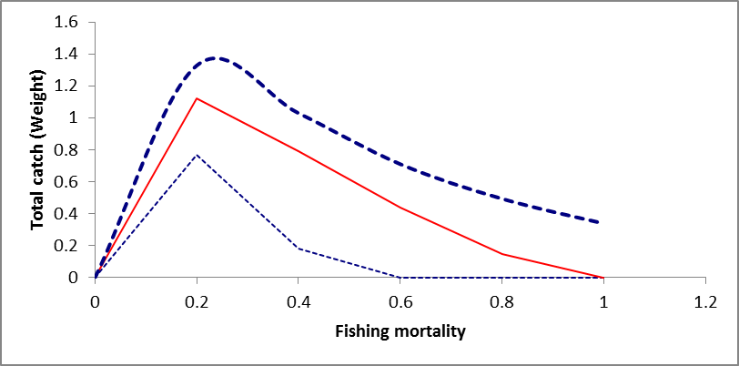
Figure 2. Catch in weight (kg) for humphead wrasse.
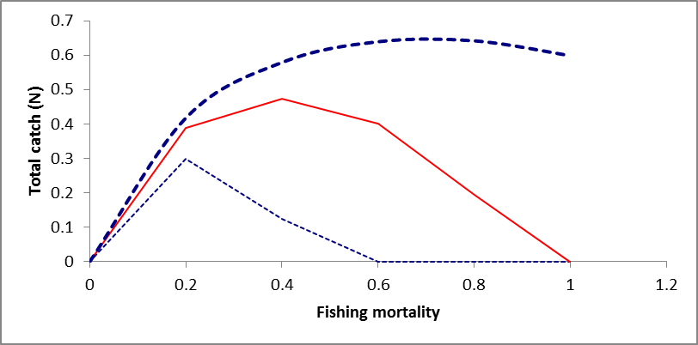
Figure 3. Catch in numbers for humphead wrasse.
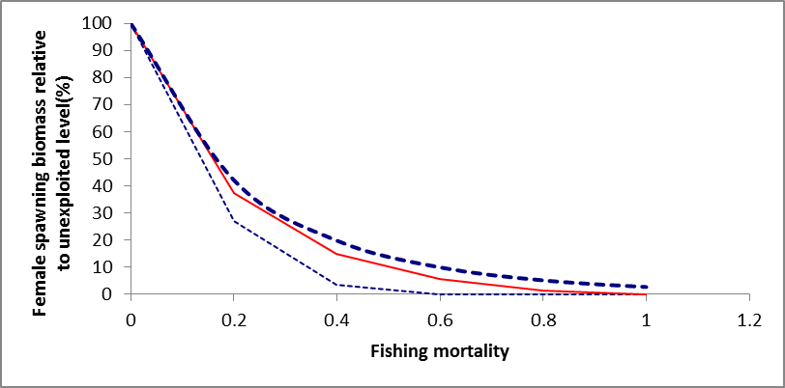
Figure 4. Spawning Stock Biomass relative to unexploited level (%) (Female)
Bumphead Parrotfish (Kemedukl)
Currently, reproductive parameters for bumphead parrotfish are not available, thus we used humphead wrasse’s reproductive output parameters (e.g. steepness and gonad weight) to simulate optimum fishing mortality. Additionally, length to weight conversion parameters are not available for this species, therefore we used the parameters for Chlorurus microrhinos, which is similar in body shape.

Based on the simulation model of Sadovy et al. (2007), optimum fishing mortality was calculated to be 0.4 when calculated for maximum sustainable numbers (F_{MSY}) (Figure 5); 0.5 if we calculate by maximum sustainable biomass (F_{MSY}) (Figure 6); and 0.4 if we calculate for 20% of the virgin spawning biomass (F₂₀) (Figure 7).
Although the model suggests fishing mortality between 0.4 and 0.5, we recommend using lower fishing mortality rates since the Kemedukl population in Palau is still recovering from the stock depletion from the previous fishery. Another good reason to keep the fishing mortality low is because the previous fishery’s annual average catch was around 1,667, which is equivalent to a fishery mortality rate of 0.035.
Since our objective is not to maximize the fishery profit but to ensure sustainable level of the population, we recommend using a fishing mortality rate of 0.01. Additionally, the natural mortality rate in the model was estimated to be 0.1 based on Australian humphead wrasse populations. Since Palau is closer to the equator, and lower latitudes are known to have higher natural mortality rates, we estimated the catch limit using natural mortality rate of 0.3. Based on equation 1, corresponding catch limits for various fishing mortality rate were calculated (Table 5). Using a fishing mortality of 0.01 and natural mortality of 0.3, we recommend the catch be capped at 487 individuals (0.8% of the estimated total population). This number can be converted into a biomass of 4,922 kg, which is lower than all the previous catches except 2006 (the year before the closure).
Table 5. Sustainable catch quota for kemedukl calculated for specified fishing mortality and natural mortality. Numbers in parenthesis are standard deviations of the estimate.
Fishing mortality (F_{MSY}) | Catch Quota in kg | Catch Quota in no.
0.01 | 4922 (0-25906) | 487 (0-2203)
0.1 | 47179 (0-248317) | 4669 (0-21116)
0.2 | 90093 (0-474182) | 8916 (0-40322)

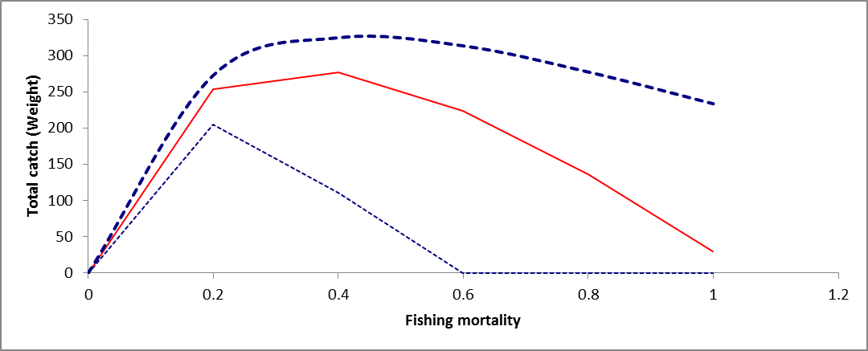
Figure 5. Catch in weight (Total) for bumphead parrotfish.

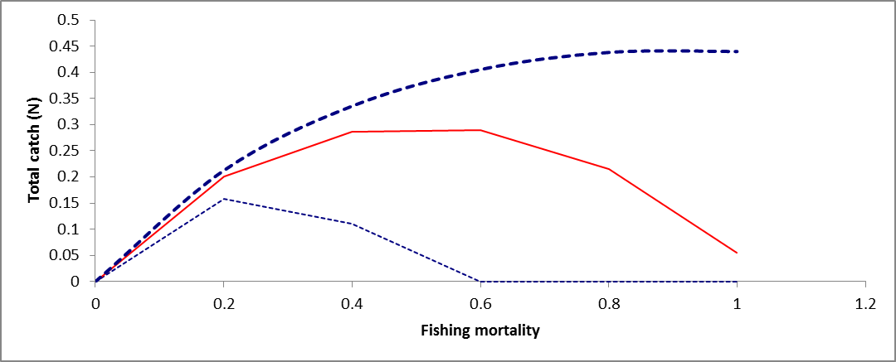
Figure 6. Catch in numbers (Total) for bumphead parrotfish.

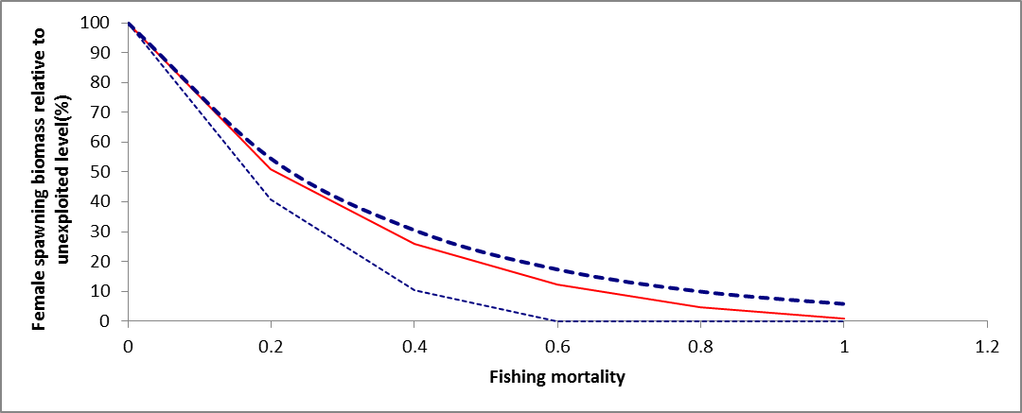
Figure 7. Number of female spawners relative to unexploited level (%) for each fishing moratality

References:
Kobayashi, D., A. Friedlander, G. Churchill, R. Nichols, and Brian Zgliczynski (2011). Bumphead Parrotfish (Bolbometopon muricatum) Status Review. NOAA Technical Memorandum NMFS-PIFSC-26. NOAA

Sadovy, Y., A.E. Punt, W. Cheung, M. Vasconcellos, S. Suharti, and B. D. Mapstone (2007). Stock assessment approach for the Napoleon fish, Cheilinus undulatus, in Indonesia. A tool for quota-setting for poor-data fisheries under CITES Appendix II Non-Detriment Finding requirements. FAO

Appendix:
The following tables show the detailed catch limit calculation for each size bin at fishing mortality rate (F)=0.01, and natural mortality rate (M)=0.3.
Maml
Size Bin (cm) | Selectivity | Mean Density (#/ha) | SD | Estimated StockSize | Calculated Catch Limit | Individual Biomass_g | Total Biomass_kg
25 | 0 | 0.11 | 0.35 | 4605.63 | 0.00 | 288.93 | 0.00
30 | 0 | 0.25 | 0.79 | 11017.87 | 0.00 | 495.55 | 0.00
35 | 0 | 0.11 | 0.34 | 4838.35 | 0.00 | 781.95 | 0.00
40 | 0 | 0.20 | 0.54 | 8541.08 | 0.00 | 1160.85 | 0.00
45 | 0 | 0.15 | 0.37 | 6442.26 | 0.00 | 1644.90 | 0.00
50 | 0 | 0.13 | 0.33 | 5609.65 | 0.00 | 2246.65 | 0.00
55 | 1 | 0.07 | 0.24 | 3207.04 | 27.58 | 2978.62 | 82.14
60 | 1 | 0.03 | 0.15 | 1383.59 | 11.90 | 3853.29 | 45.84
65 | 1 | 0.04 | 0.15 | 1554.30 | 13.36 | 4883.07 | 65.26
70 | 1 | 0.03 | 0.15 | 1205.79 | 10.37 | 6080.34 | 63.04
75 | 1 | 0.01 | 0.06 | 273.99 | 2.36 | 7457.42 | 17.57
80 | 1 | 0.04 | 0.19 | 1527.06 | 13.13 | 9026.63 | 118.52
85 | 1 | 0.02 | 0.10 | 672.09 | 5.78 | 10800.23 | 62.41
90 | 1 | 0.04 | 0.21 | 1867.00 | 16.05 | 12790.46 | 205.33
100 | 1 | 0.05 | 0.20 | 2072.91 | 17.82 | 17469.58 | 311.38
105 | 1 | 0.01 | 0.10 | 442.86 | 3.81 | 20182.81 | 76.85
110 | 1 | 0.01 | 0.08 | 380.90 | 3.28 | 23161.33 | 75.86
120 | 1 | 0.01 | 0.08 | 380.90 | 3.28 | 29962.62 | 98.13
Total |  |  |  |  | 128.72 |  | 1222.33

Kemedukl (at fishing mortality rate (F)=0.01, and natural mortality rate (M)=0.3)
Size Bin (cm) | Selectivity | Mean Density (#/ha) | SD | Estimated StockSize | Calculated Catch Limit | Individual Biomass_g | Total Biomass_kg
15 | 0 | 0.01 | 0.13 | 587.30 | 0.00 | 50.51 | 0.00
20 | 0 | 0.03 | 0.18 | 1173.34 | 0.00 | 121.46 | 0.00
25 | 0 | 0.02 | 0.16 | 1041.32 | 0.00 | 239.88 | 0.00
30 | 0 | 0.05 | 0.28 | 2019.19 | 0.00 | 418.31 | 0.00
35 | 0 | 0.05 | 0.21 | 2167.29 | 0.00 | 669.40 | 0.00
40 | 0 | 0.14 | 0.56 | 6147.42 | 0.00 | 1005.91 | 0.00
45 | 0 | 0.10 | 0.38 | 4249.40 | 0.00 | 1440.70 | 0.00
50 | 0 | 0.14 | 0.42 | 5923.55 | 0.00 | 1986.71 | 0.00
55 | 1 | 0.15 | 0.41 | 6680.80 | 57.44 | 2656.94 | 152.63
60 | 1 | 0.17 | 0.41 | 7381.42 | 63.47 | 3464.47 | 219.89
65 | 1 | 0.05 | 0.21 | 2111.52 | 18.16 | 4422.43 | 80.29
70 | 1 | 0.12 | 0.29 | 5192.03 | 44.64 | 5544.02 | 247.51
75 | 1 | 0.06 | 0.22 | 2429.41 | 20.89 | 6842.46 | 142.93
80 | 1 | 0.12 | 0.33 | 5141.40 | 44.21 | 8331.06 | 368.30
85 | 1 | 0.06 | 0.23 | 2767.31 | 23.79 | 10023.13 | 238.50
90 | 1 | 0.19 | 0.43 | 8464.03 | 72.78 | 11932.05 | 868.39
95 | 1 | 0.04 | 0.17 | 1540.68 | 13.25 | 14071.25 | 186.41
100 | 1 | 0.16 | 0.58 | 6831.45 | 58.74 | 16454.16 | 966.52
105 | 1 | 0.12 | 0.98 | 5358.14 | 46.07 | 19094.27 | 879.71
110 | 1 | 0.05 | 0.20 | 2073.80 | 17.83 | 22005.10 | 392.38
120 | 1 | 0.01 | 0.07 | 314.54 | 2.70 | 28693.16 | 77.60
125 | 1 | 0.01 | 0.08 | 361.21 | 3.11 | 32497.59 | 100.93
Total |  |  |  |  | 487.08 |  | 4921.99

