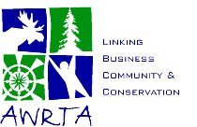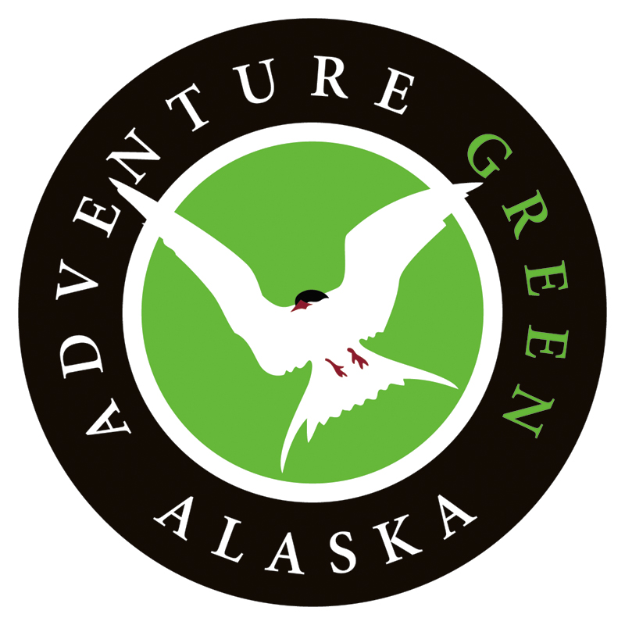

FOR IMMEDIATE RELEASE CONTACT:
September 9, 2008 Dan Oberlatz – (907) 301-9997
Owner, Alaska Alpine Adventures
Vice President, AWRTA

ALASKA TOURISM CERTIFICATION PROGRAM LAUNCHED
Trade Association Promotes Sustainable Tourism in the Great Land

Anchorage, AK--The Alaska Wilderness Recreation & Tourism Association (AWRTA) today announced Adventure Green Alaska (AGA), a voluntary certification program for tourism businesses operating in Alaska that meet standards of economic, social, and environmental sustainability. Businesses may qualify for Gold, Silver, or Bronze Level certification, earning the right to use the AGA label and participate in AGA promotional activities.

“We are excited to announce the first tourism certification program in Alaska,” said Kent John, AWRTA’s President and owner of the Great Alaska Adventure Lodge in Sterling, Alaska. “This program will help promote businesses that are using green practices and encourage other businesses to do the same.”

Ginny Fay, an economist and former Alaska State Tourism Director, said that tourism is becoming one of the world’s largest industries and Alaska is in a unique position to take advantage of this trend. “In other tourism destinations, community and business leaders have encouraged sustainable forms of tourism that minimize impacts on natural areas, respect indigenous peoples, and benefit local economies. These destinations are experiencing robust economic development,” said Fay.

“Our goal is to attract travelers to sustainable businesses and provide an economic incentive for other businesses to improve their operations,” said John. “Adventure Green Alaska is good for the environment, good for communities in Alaska, and good for our bottom line.”

Adventure Green Alaska, the first certification program of its kind in Alaska, was
developed in partnership with tourism business owners, industry consultants, and
conservation group representatives. AGA is now accepting applications which can be accessed online at www.awrta.org. Businesses submitting applications by December 1, 2008 will be eligible for certification in January 2009.

The Alaska Wilderness Recreation & Tourism Association is a nonprofit trade association representing over 100 wilderness-dependent businesses and communities. For further information about AWRTA, please visit www.awrta.org.

###

