Updates on TNC related fisheries efforts in Palau and Micronesia
Data poor stock assessment – using the data poor stock assessment technique, basically estimating the spawning potential through determining size at maturity, we have worked with fishermen from two communities in the northern reefs of Palau to collect fishermen catch data. Results show that 60% of fish being caught are immature. We are able to make initial estimate of the status of the stock for the following species Spotcheek Snapper (1% spawning), Humpback Snapper (2% spawning). Lyre Tail Grouper (3% spawning). We continue to collect catch data to assess spawning potential for other important species. There are a total of 31 reef fish species, which includes several species of emperor fish, parrotfish, grouper, surgeonfish, rabbitfish, and wrasse that are locally important.

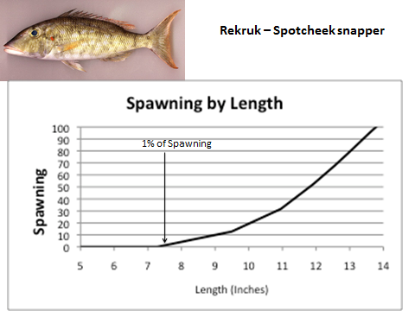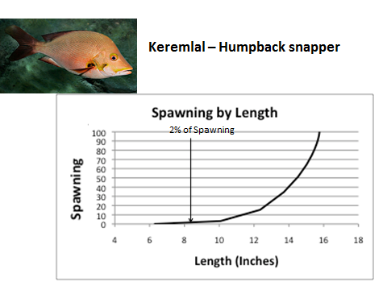

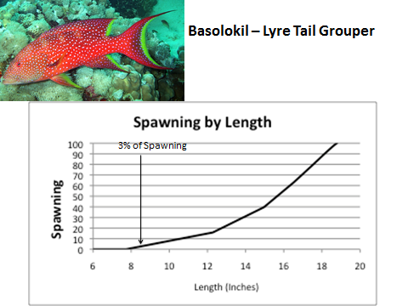

We are working with the Palau Bureau of Marine Resource to expand collection of fishermen’s catch. Export Data collection at the Palau International Airport is being improved to collect species weight and total weight of export starting on May 1, 2013. Starting on June 1, 2013, data collection at the only local fish market will commence where total species weight, and individual species length and gonad status will be collected. This is being done to collect data to allow us to understand current stock status of the most important reef fisheries species and to allow for implementation of additional management strategies.

Territorial Underwater Rights Fishing (TURF)
Rights based and fisheries cooperatives management – In an effort to get more fishermen and community involved in fisheries management, we have initiated dialogues with community of Ngarchelong and Kayangel (communities who owns the northern reefs) to discuss possibilities of instituting rights based fisheries management through fisheries cooperatives. Fisheries meetings with leadership of both communities will take place on June 25 and June 27 to initiate the initial process for charting a vision and the course for implementing rights based fisheries as well as discussion of possibilities of enhancing clam aquaculture to help alleviate the fishing pressure to allow fish stocks to recover.

